**Now you will see a poster.**

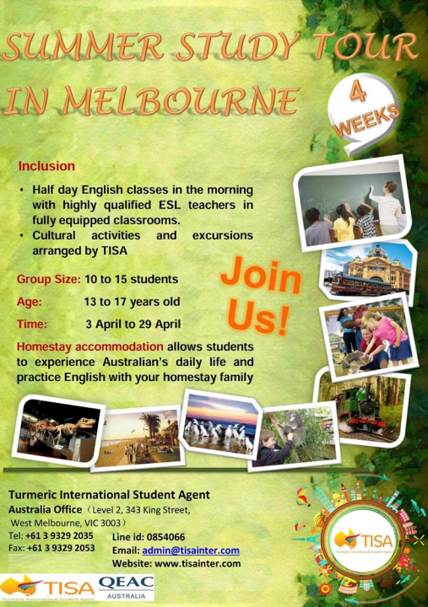

***Task 1 Presentation:***

**Suppose you are a staff member of Turmeric International Student Agent and you are receiving a person who is interested in the summer study tour.**

**You will recommend and introduce your product or service to the person.**

***Task 2 Interview:***

**Suppose you are a staff member of Turmeric International Student Agent and you are receiving a person who is interested in the summer study tour.**

**You will answer questions from the person.**

**Contestant: A staff member of Turmeric International Student Agent**

**Question Master: A person who is interested in the summer study tour**